Week 3 CAD Internship Mini-Project Report: Engine Piston & Connecting Rod Assembly

1. Project Title & Overview
- Project Name: Design and Assembly of an Internal Combustion Engine Piston and Connecting Rod Assembly
- Internship Track: Computer-Aided Design (CAD)
- Author: HARSH RAJ SINGH
- Date: 14-10-26

2. Executive Summary
This project focuses on the end-to-end design, modeling, and assembly of a high-performance internal combustion engine piston and connecting rod mechanism using industrial CAD software. The objective was to create a functional, interference-free parametric 3D assembly optimized for structural integrity and dynamic clearance. All components—including the piston crown, connecting rod, gudgeon pin, and fasteners—were modeled independently and assembled using accurate kinematic mates.

3. Design Objectives & Problem Statement
The primary goal of this mini-project is to demonstrate independent engineering decision-making in CAD modeling and assembly design. Specific objectives include:
- Creating 3D parametric models with proper dimensional constraints.
- Applying fit tolerances and material specifications suitable for high-stress automotive environments.
- Utilizing concentric, coincident, and distance mates to form a fully constrained dynamic assembly.
- Generating clear technical documentation, exploded views, and bill of materials (BOM).

4. Technical Specifications & Material Selection
Component | Key Dimensions | Assigned Material | Reason for Material Selection
Piston Head | $72\,\text{mm}$ Diameter | Cast Aluminum Alloy | Lightweight, high thermal conductivity, low thermal expansion
Connecting Rod | $145\,\text{mm}$ Center-to-Center Length | Forged Structural Steel | High tensile and fatigue strength to endure cyclic combustion loads
Gudgeon (Piston) Pin | $22\,\text{mm}$ Outer / $10\,\text{mm}$ Inner Diameter | Case-Hardened Alloy Steel | High surface hardness to resist shear and wear
Rod Bolts | M12 Metric Thread | High-Tensile Steel | Secure clamping force on the big-end rod cap

5. Step-by-Step Design Methodology

Phase 1: Individual Component Modeling
- Piston Head: Sketched the outer profile and revolved the main body. Cut ring grooves into the crown and extruded internal mounting bosses with draft angles for manufacturability.
- Connecting Rod: Created the small-end and big-end bores using concentric circles. Extruded an H-beam profile between them for optimal strength-to-weight ratio. Split the big-end to create the detachable rod cap.
- Gudgeon Pin & Fasteners: Extruded hollow cylindrical pins and created standard M12 threaded bolts using cosmetic threads and helical cuts.

Phase 2: Assembly & Mating
- Concentric Mates: Aligned the gudgeon pin inside the small-end rod bore and the piston pin holes.
- Coincident & Distance Mates: Centered the connecting rod axially within the internal piston cavity to prevent lateral slop while permitting smooth angular oscillation.
- Rod Cap Attachment: Fixed the rod cap to the main rod body using M12 bolt fasteners.

Phase 3: Verification & Rendering
- Performed Interference Detection to verify zero overlap between mating components.
- Configured realistic material textures (brushed aluminum, forged steel) and generated rendered views along with an exploded assembly diagram.

6. Project Visuals & Documentation

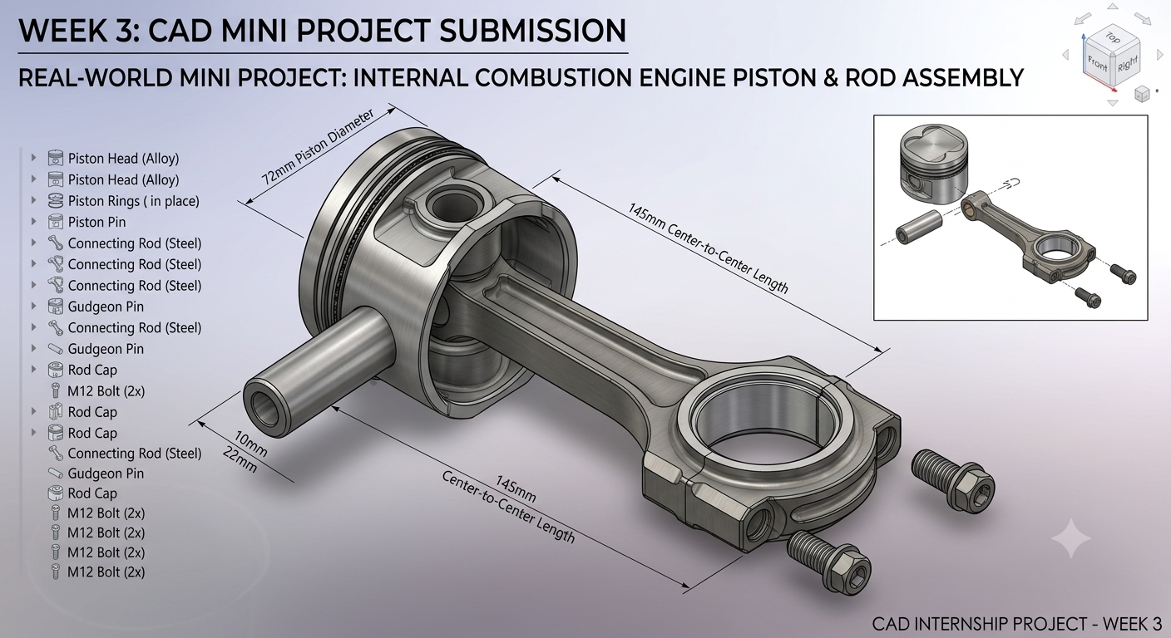
- Figure 1: Isometric render showing fully assembled piston and connecting rod with key callout dimensions, exploding assembly inset, and feature tree hierarchy.

7. Results & Key Learnings
- Fit and Motion: The assembly successfully maintains free angular rotation along the pin axis while eliminating axial displacement errors.
- CAD Skills Mastered: Advanced parametric sketching, multi-body component separation, assembly mate relations, bill-of-materials generation, and visual render preparation.
- Design Considerations: Gained practical understanding of drafting angles, wall thickness consistency, and stress concentration mitigation in mechanical parts.

